**Arithmetic Operations in MATLAB**

**Objective:**

To provide hands-on practice in MATLAB, covering arithmetic operations and vector operations

1. Perform the following calculations in MATLAB

* 1. 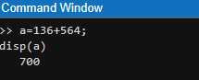136+564

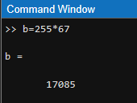 b. 255×67

c. 12.36/5.68

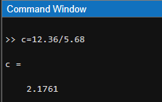

d. 

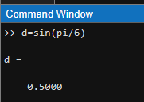

e. 𝑒0.76

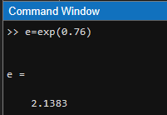

f. √5

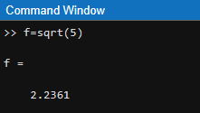

g. K =(3 + 2(32 + √8)3

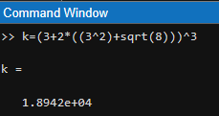

1. Enter the following variables: a = 123456, b= 3(1/4), c = cos .

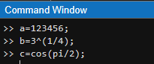Now calculate

* 1. 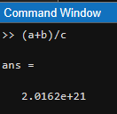(a+b)/c
  2. 2a - 3b

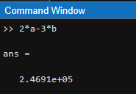

* 1. 

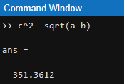

* 1. a / (3b + 4c)

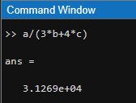

e. exp(𝑎1/4 − 𝑏10)

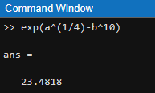

1. Find the MATLAB functions for the inverse trigonometric functions; 𝑠𝑖𝑛−1 , 𝑐𝑜𝑠−1 𝑡𝑎𝑛−1. Then calculate;

* 1. 𝑠𝑖𝑛−1(0.5)

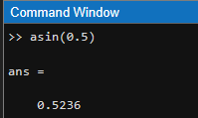

* 1. 𝑐𝑜𝑠−1(√3/2)

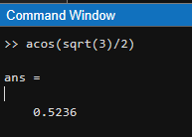

* 1. 𝑡𝑎𝑛−1(2)

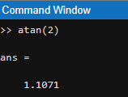

* 1. Convert your answers from radians to degrees.

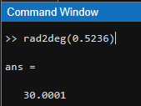 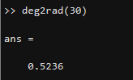

1. Using vectorization and the colon operator, use a single command each to generate.

* 1. The first 15 cubes

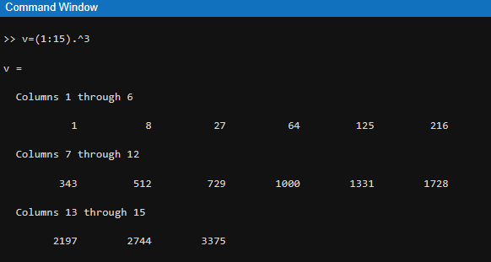

* 1. The values sin ( ) for n from 1 to 16

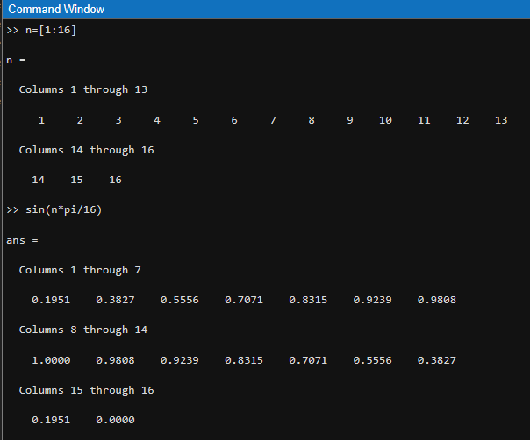

* 1. The values √𝑛 for n from 10 to 20 (Do it in two methods)

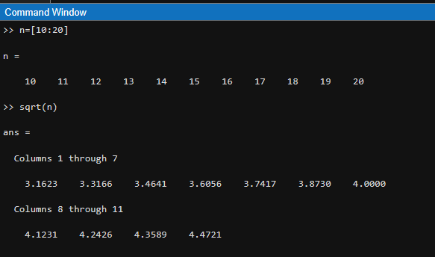

1. a. Plot the function tan(x) with the following commands x= [0:0.1:10]; plot(x,tan(x))

figure, plot(x,tan(x)), axis([0,10 ,- 10,10])

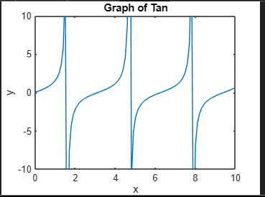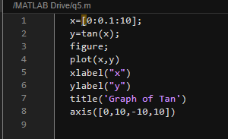

b. Plot the multiple functions on the same graph using “hold” command x = 0 : 0.1 : 10 functions: 𝑥2 and 𝑥3

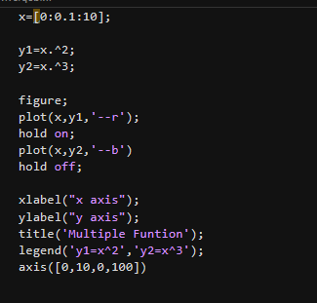

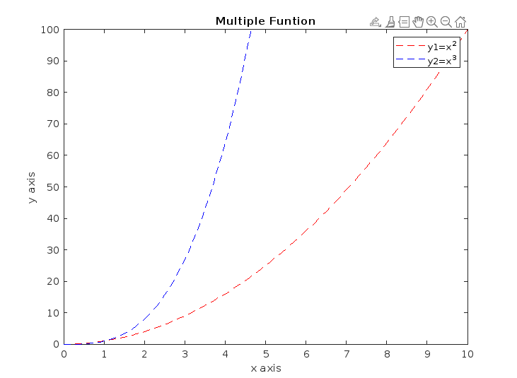

1. Extra Exercises
   * 1. Write a MATLAB code to verify the following trigonometric identity at x = 𝜋/3.

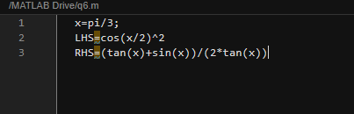

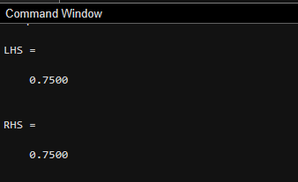

* + 1. Calculate the sum of the even numbers between 2 to 20 and display the output using “disp” command.

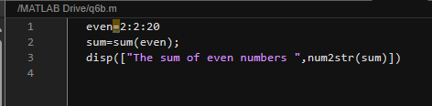

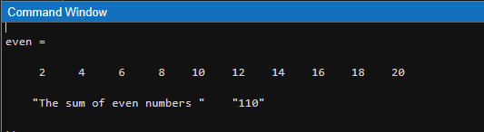

* + 1. Convert the temperature value Celsius to Fahrenheit Output:

Enter the temperature in Celsius: 30

Temperature in Fahrenheit: 80

